**MICROSTIP PATCH ANTENNA**

**PRE-LAB:**

* What is a Patch Antenna?
* What are the different parameters of a patch antenna?

**OBJECTIVES:**

Design a Microstrip Patch Antenna which is radiating at 5.2GHz using HFSS software and analyze various parameters of an antenna

**REQUIREMENTS:**

* Personal Computer
* ANSYS-HFSS Simulation software 17.0

**DESIGN LAYOUT:**

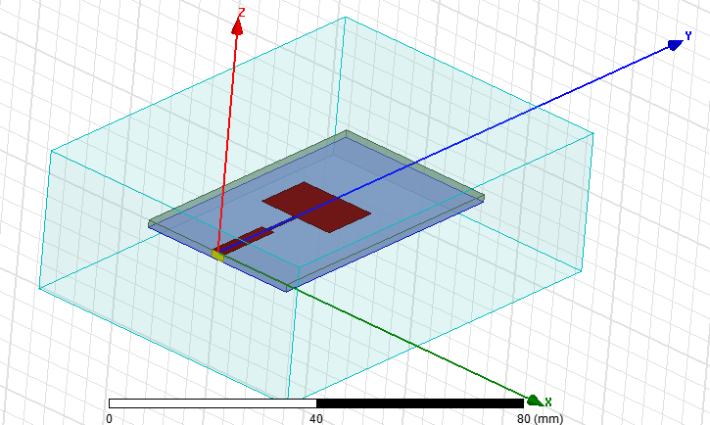

**THEORY:**

**A patch antenna** (also known as a rectangular microstrip antenna) is a type of radio antenna with a low profile, which can be mounted on a flat surface. It consists of a flat rectangular sheet or "patch" of metal, mounted over a larger sheet of metal called a ground plane. They are the original type of microstrip antenna described by Howell in 1972 the two metal sheets together form a resonant piece of microstrip transmission line with a length of approximately one-half wavelength of the radio waves. The radiation mechanism arises from discontinuities at each truncated edge of the microstrip transmission line. The radiation at the edges causes the antenna to act slightly larger electrically than its physical dimensions, so in order for the antenna to be resonant, a length of microstrip transmission line slightly shorter than one-half a wavelength at the frequency is used. The microstrip antennas are having the advantage of low profile, low cost ease of fabrication and can be easily integrated into any microwave circuitry. The basic microstrip patch is as shown in the below figure.1. The patch is generally made of conducting material such as copper or gold and can take any possible shape. The radiating patch and the feed lines are usually photo etched on the dielectric substrate.



Fig.1. Microstrip patch antenna

Consider the microstrip antenna shown in Figure 1, fed by a microstrip transmission line. The patch antenna, microstrip transmission line and ground plane are made of high conductivity metal generally copper. The patch length L, Width W, and sitting on top of a substrate of thickness h with permittivity εr.

The thickness of ground plane or of the microstrip is not critically important. Typically the height is much smaller than the wavelength of operation, but should not be much smaller than 0.025 of a wavelength (1/40th of a wavelength) or the antenna efficiency will be degraded.

The frequency of operation of the patch antenna of figure.1 is determined by the length L, the center frequency will be approximately given by:

center frequency of operation for patch antenna

The above equation says that the microstrip antenna should have a length equal to one half of a wavelength within the dielectric (substrate) medium.

The width *W* of the microstrip antenna controls the input impedance. Larger widths also can increase the bandwidth. For a square patch antenna fed in the manner above, the input impedance will be on the order of 300 Ohms. By increasing the width, the impedance can be reduced. However, to decrease the input impedance to 50 Ohms often requires a very wide patch antenna, which takes up a lot of valuable space. The width further controls the [radiation pattern](http://www.antenna-theory.com/basics/radpattern.php). The normalized radiation pattern is approximately given by:

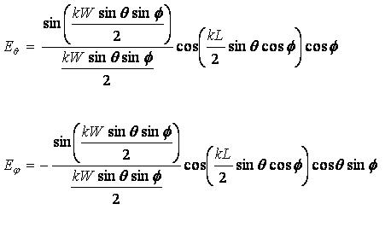

In the above, *k* is the free-space [wavenumber](http://www.antenna-theory.com/definitions/wavenumber.php), given by wavenumber. The magnitude of the fields, given by:

magnitude of radiated fields

The fields of the microstrip antenna are plotted in Figure 2 for *W*=*L*=0.5http://www.antenna-theory.com/basics/lambda.bmp.

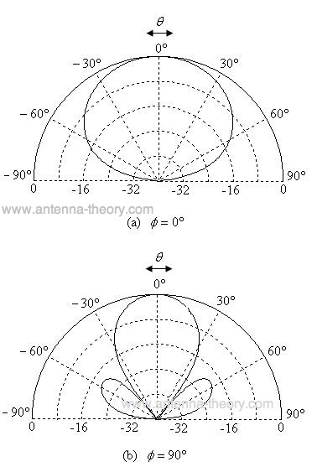

Figure 2. Normalized Radiation Pattern for Microstrip (Patch) Antenna.

The directivity of patch antennas is approximately 5-7 dB. The fields are linearly polarized, and in the horizontal direction when viewing the microstrip antenna.The corresponding return loss of the antenna is given by

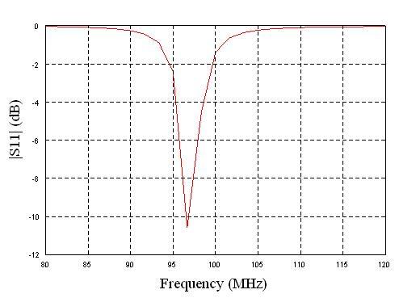

Figure 3. Magnitude of S11 versus Frequency for Square Patch Antenna.

From Figure, it can be noted that the bandwidth of the patch antenna is very small. Rectangular patch antennas are notoriously narrowband; the bandwidth of rectangular microstrip antennas are typically 3%. Secondly, the resonant frequency can have a slight change from the design due to the effect of fringing fields.

**DESIGN EQUATIONS:**

The Performance of the Microstrip patch antenna depends on its resonant frequency dimensions. Depending upon the dimensions, the operating frequency, radiation efficiency, directivity, return loss are influenced. For an efficient radiation, the practical width (W) and length (L) of the patch can be calculated by using the following.





Where, 



Where is the wave length, fr is the resonant frequency, L and W are the length and width of the patch element respectively and is the dielectric constant.

1. **Substrate Creation**

* Select the menu item **DRAW** > **BOX**
* Enter position and dimensions of the **Substrate (box)**
* Click the **OK** button

|  |  |
| --- | --- |
| Name | Substrate Dimensions in (mm) |
| Position | -17.95, 0, 0 |
| X size | 35.9 |
| Y size | 58.94 |
| Z size | -1.6 |

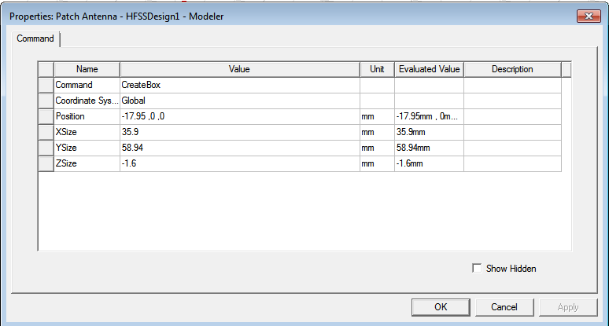 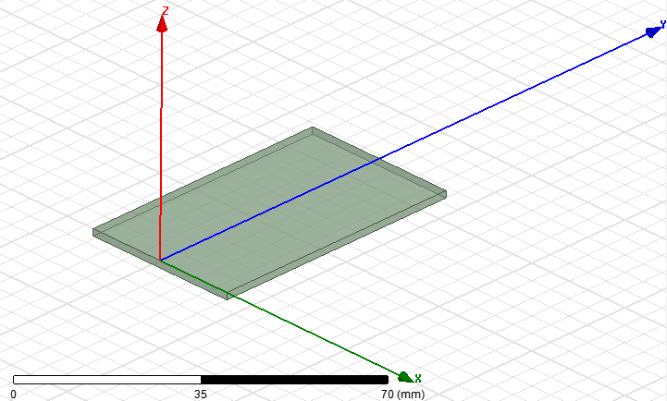

1. **Assigning Substrate material**

* Double click Box1 in the history box
* Change name as **Substrate** and material as FR-4 epoxy
* Select the color and transparency
* Click the **OK** button

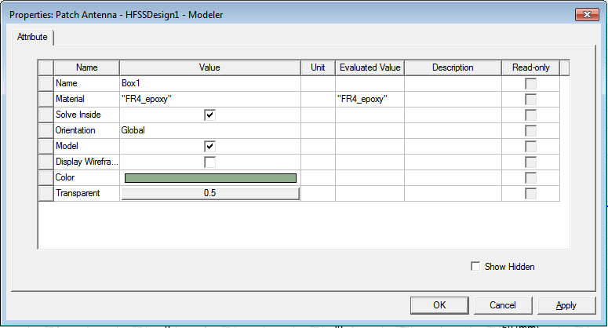

1. **Patch Creation**

* Select menu item **DRAW > RECTANGLE**
* Enter position and dimensions of the Rectangle
* Click the **OK** button
* Double Click Rectangle in the history box
* Change the name as **Patch**
* Select the color and transparency
* Click the **OK** button

|  |  |
| --- | --- |
| Name | Patch Dimensions in (mm) |
| Position | -8.78, 23.19, 0 |
| Axis | Z |
| X size | 17.56 |
| Y size | 12.56 |

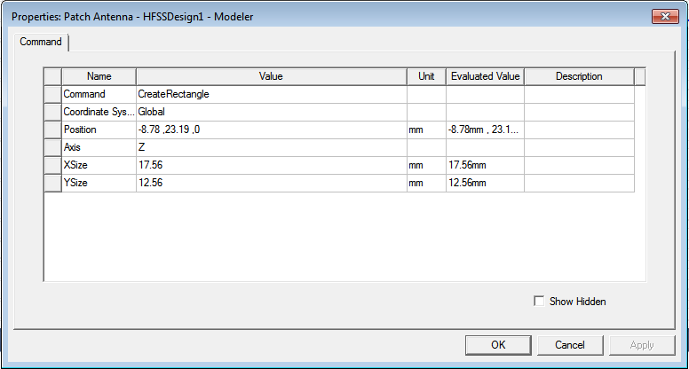 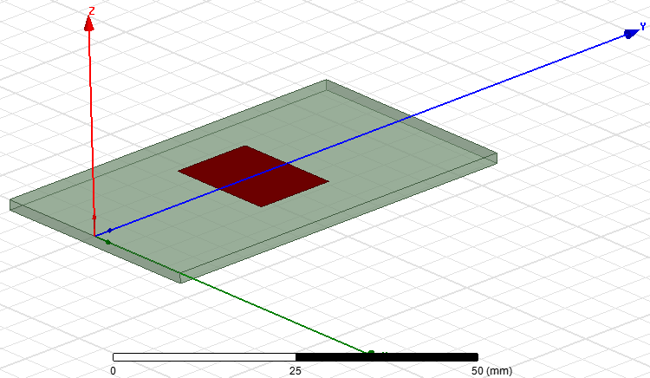

1. **Create Feed Line**

* Select the menu item **DRAW** > **RECTANGLE**
* Enter position and dimensions of the Rectangle
* Click **OK** button
* Double Click Rectangle in the history box
* Change the name as **feed line**
* Select the color and transparency
* Click the **OK** button

|  |  |
| --- | --- |
| Name | Feed Line Dimensions in (mm) |
| Position | -1.5295, 0, 0 |
| Axis | Z |
| X size | 3.059 |
| Y size | 14.896 |

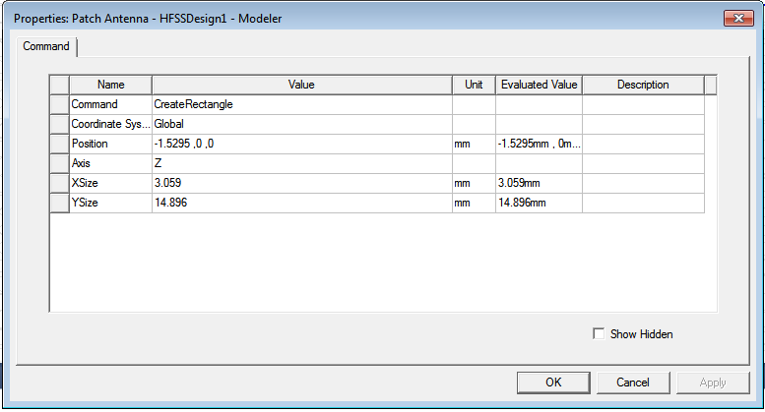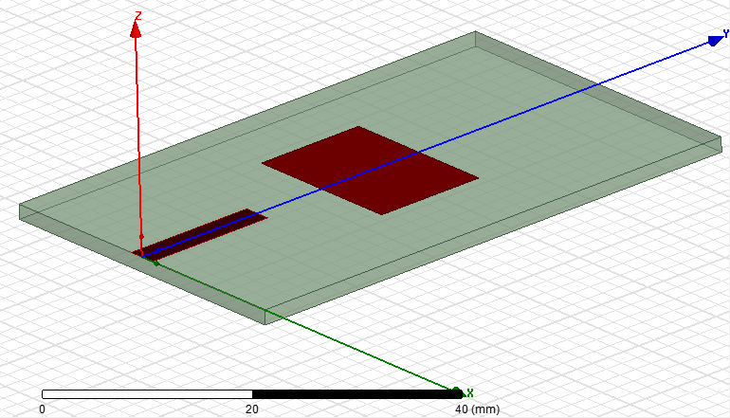

1. **Create Quarter Wave Transformer (QWT)**

* Select the menu item **DRAW** > **RECTANGLE**
* Enter position and dimensions of the Rectangle
* Click **OK** button
* Double Click Rectangle in the history box
* Change the name as **QWT**
* Select the color and transparency
* Click the **OK** button

|  |  |
| --- | --- |
| Name | QWT Dimensions in (mm) |
| Position | -0.3615, 14.896, 0 |
| Axis | Z |
| X size | 0.723 |
| Y size | 8.924 |

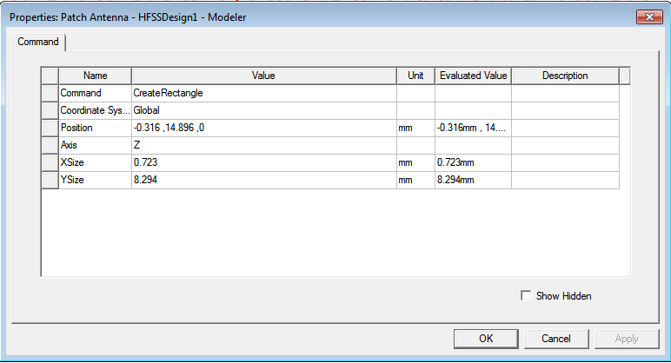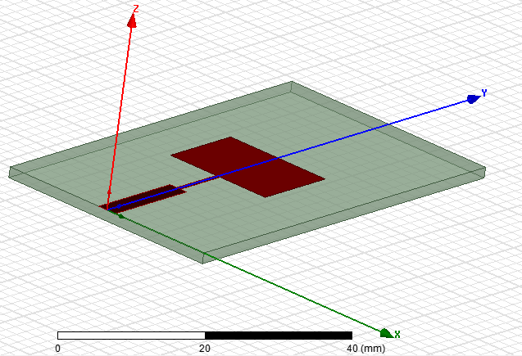

1. **Create Ground Geometry**

* Select the menu item **DRAW** > **RECTANGLE**
* Enter position and dimensions of the Rectangle
* Click **OK** button
* Double Click Rectangle in the history box
* Change the name as **Ground**
* Select the color and transparency
* Click the **OK** button

|  |  |
| --- | --- |
| Name | Substrate Dimensions in (mm) |
| Position | -17.95, 0, -1.6 |
| Axis | Z |
| X size | 35.9 |
| Y size | 58.94 |

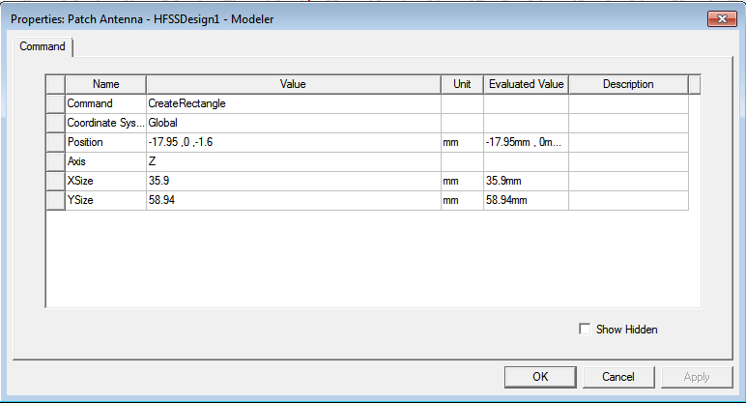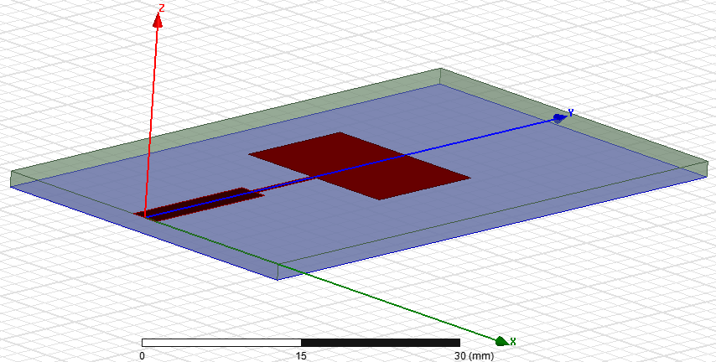

1. **Uniting Patch, Feed Line and QWT**

* From the history box select Patch, Feed Line and QWT using Ctrl tab and Right Click
* Go to **EDIT** > **BOOLEAN** > **UNITE**

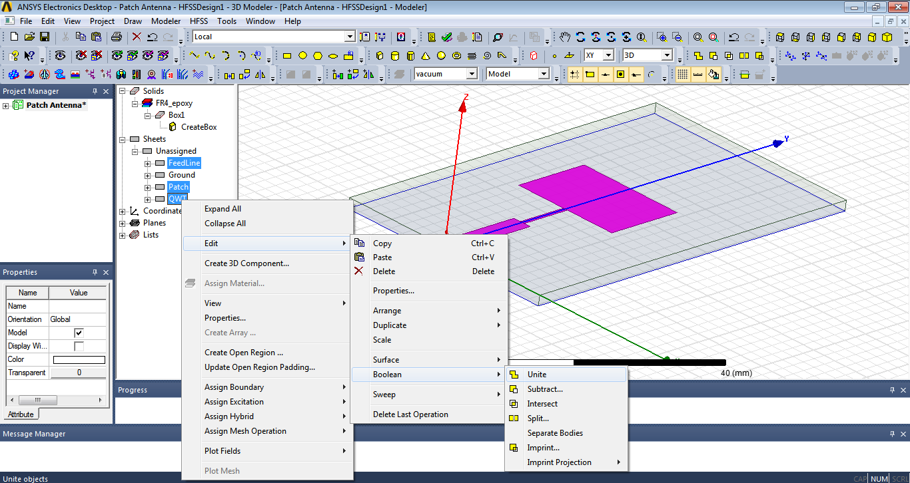

1. **Assign Boundary**

* Go to the history box select Patch and Ground using Ctrl tab and Right Click
* Choose **Assign Boundary** > **perfect E**
* Click the **OK** button

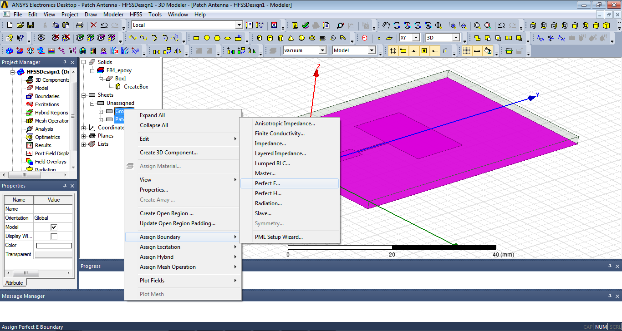

1. **Create Air Box**

* Select the menu item **DRAW** > **BOX**
* Enter position and dimensions of the Box
* Click **OK** button
* Double Click Box in the history box
* Change the name as **Radiation Box**
* Select the material as **Vacuum**
* Select the color and transparency
* Click the **OK** button

|  |  |
| --- | --- |
| Name | Air Box Dimensions in (mm) |
| Position | -32.37, 14.42, -16.02 |
| X size | 64.74 |
| Y size | 87.78 |
| Z size | 30.44 |

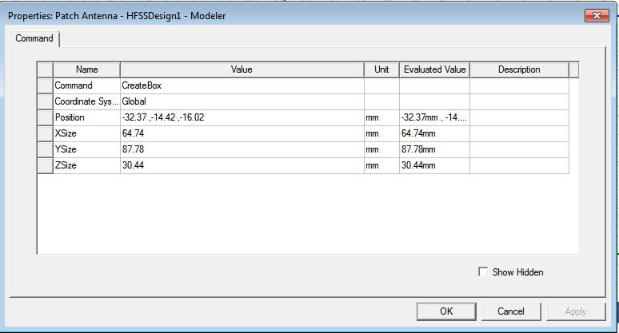 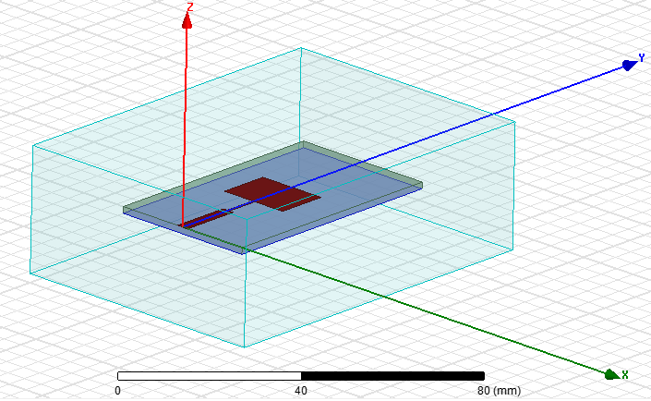

1. **Assign Boundary Condition - Radiation**

* Go to the history box select Radiation Box and Right Click on it
* Choose **Assign Boundary** > **Radiation**
* Click the **OK** button

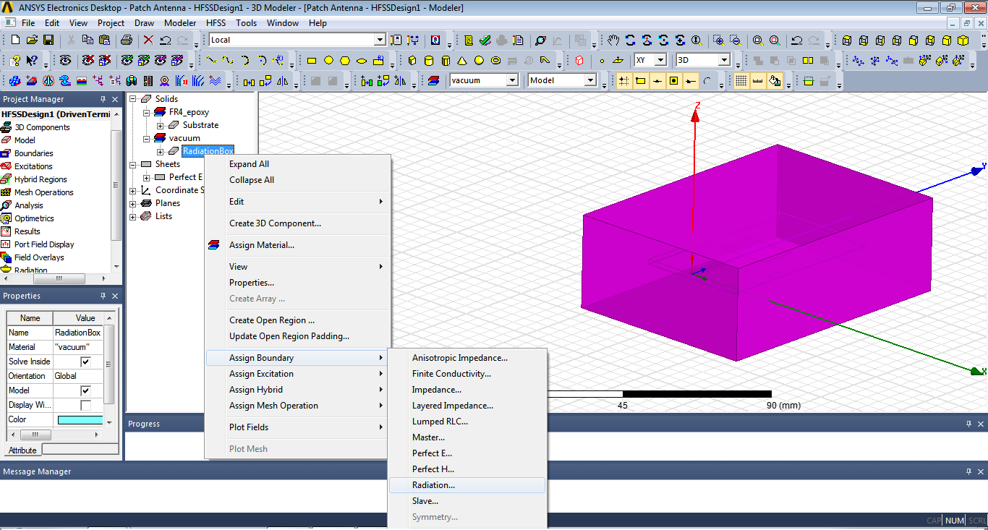

1. **Port Setup**

Create Rectangle used for Lumped Port

* Set the Drawing Grid Plane
* Select the menu item **MODELER** > **GRID PLANE** > **ZX**
* Select the menu item **DRAW** > **RECTANGLE**
* Enter position and dimensions of the Rectangle
* Click **OK** button
* Double Click Rectangle in the history box
* Change the name as **PORT**
* Select the color and transparency
* Click the **OK** button

|  |  |
| --- | --- |
| Name | Substrate Dimensions in (mm) |
| Position | -1.5295, 0, 0 |
| Axis | Y |
| X size | 3.059 |
| Z size | -1.6 |

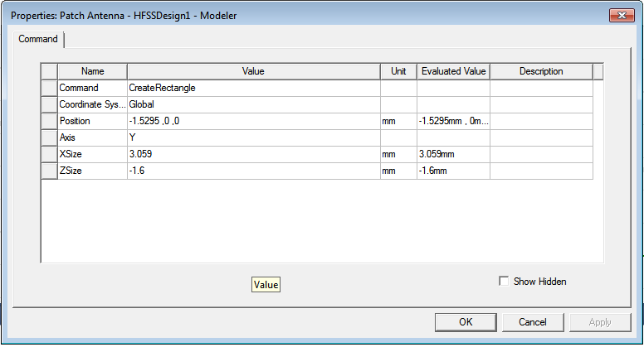 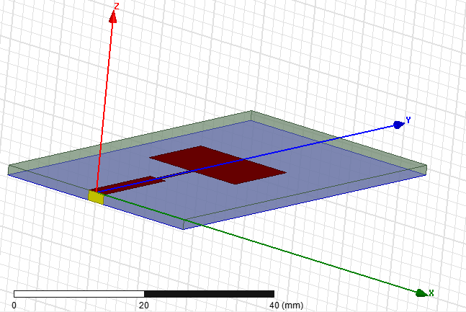

1. **Assign Excitation**

* Go to the history box select **Port** and Right Click on it
* Choose **Assign Excitation** > **Lumped Port** > select **Reference** as **Ground**
* Click the **OK** button

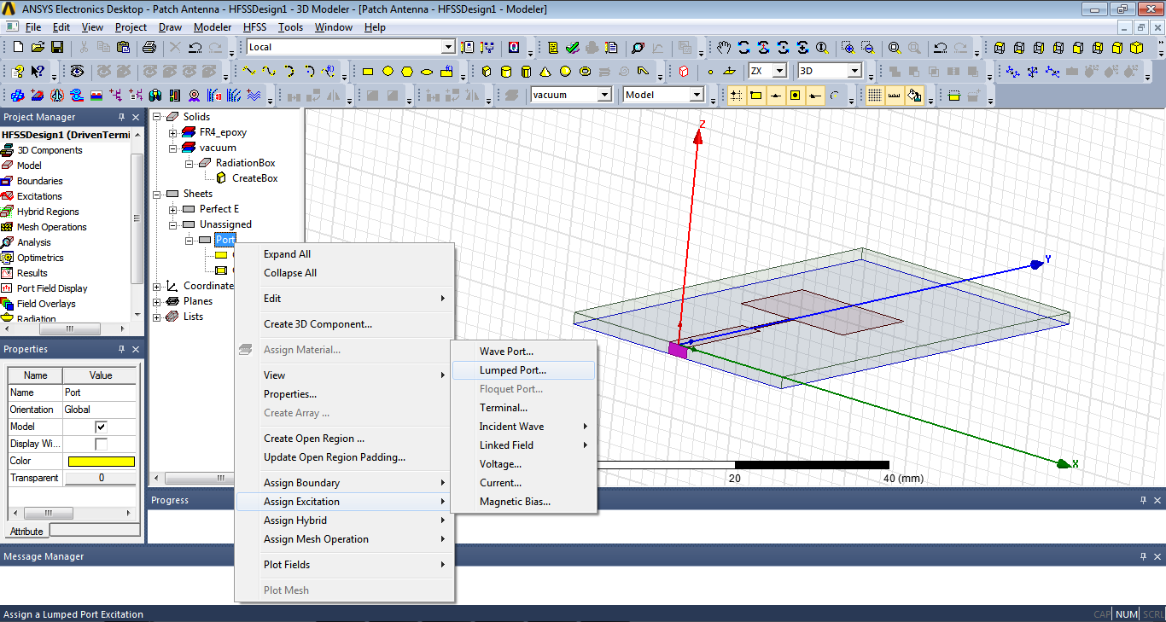 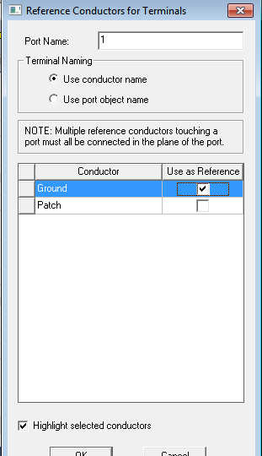

1. **Analysis Setup**

* Go to **Project Manager** window select **Analysis** right click on it, go to **Add Solution Setup**
* Now add Solution Frequency as 5.2 GHz
* Click on **OK** button

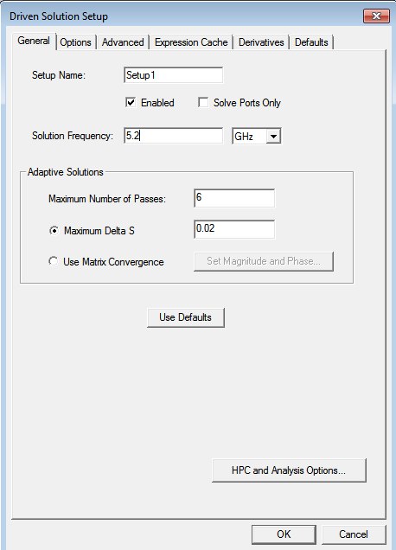

1. **Adding Frequency Sweep**